What is Cloud Computing?

[Cloud computing](https://www.simplilearn.com/tutorials/cloud-computing-tutorial/what-is-cloud-computing) is the delivery of online services (such as servers, databases, software) to users. With the help of cloud computing, storing data on local machines is not required. It helps you access data from a remote server. Moreover, it is also used to store and access data from anywhere across the world.

AWS?

s an online platform that provides scalable and cost-effective cloud computing solution.AWS is a broadly adopted cloud platform that offers several on-demand operations like compute power, database storage, content delivery, etc., to help corporates scale and grow.

## Applications of AWS

### Storage and Backup

### 2. Websites

### 3. Gaming

### Mobile, Web and Social Applications

## AWS Services

* Compute service
* Storage
* Database
* Networking and delivery of content
* Security tools
* Developer tools
* Management tools

## What is Cloud Computing?

[Cloud computing](https://www.simplilearn.com/tutorials/cloud-computing-tutorial/what-is-cloud-computing) is the delivery of online services (such as servers, databases, software) to users. With the help of cloud computing, storing data on local machines is not required. It helps you access data from a remote server. Moreover, it is also used to store and access data from anywhere across the world.

## (AWS) is a highly available, secure cloud services platform that offers more than 100 cloud applications. Providing a pay-as-you-go system removes the requirement for capital to be provided upfront. It helps in controlling, auditing, and managing identity, configuration, and usage.

[Amazon web service](https://www.simplilearn.com/tutorials/aws-tutorial/aws-fundamentals) is an online platform that provides scalable and cost-effective cloud computing solutions.

AWS is a broadly adopted cloud platform that offers several on-demand operations like compute power, database storage, content delivery, etc., to help corporates scale and grow.

## Applications of AWS

AWS enables businesses to build a number of sophisticated applications. Organizations of every industry and of every size, can run every imaginable use case on AWS. Here are some of the most common applications of AWS:

### 1. Storage and Backup:

One of the reasons why many businesses use AWS is because it offers multiple types of storage to choose from and is easily accessible as well. It can be used for storage and file indexing as well as to run critical business applications.

### 2. Websites:

Businesses can host their websites on the AWS cloud, similar to other web applications.

### 3. Gaming:

There is a lot of computing power needed to run gaming applications. AWS makes it easier to provide the best online gaming experience to gamers across the world.

### 4. Mobile, Web and Social Applications

A feature that separates AWS from other cloud services is its capability to launch and scale mobile, e-commerce, and [SaaS applications](https://www.simplilearn.com/what-is-saas-article). API-driven code on AWS can enable companies to build uncompromisingly scalable applications without requiring any OS and other systems.

## Companies using AWS

Whether it’s technology giants, startups, government, food manufacturers or retail organizations, there are so many companies across the world using AWS to develop, deploy and host applications. According to Amazon, the number of active AWS users exceeds 1,000,000. Here is a [list](https://aws.amazon.com/solutions/case-studies/) of companies using AWS:

* Netflix
* Intuit
* Coinbase
* Finra
* Johnson & Johnson
* Capital One
* Adobe
* Airbnb
* AOL
* Hitachi

## Advantages of AWS Services:

The power of AWS services lies in the fact that it enables businesses to reach the marketplaces with little initial investment. Here are some advantages of AWS services:

### 1. Security:

There is a false misconception that data stored in a public cloud is not secure. On the contrary, not only does AWS offer security tools that are cheaper than other alternatives, but it is one of the most secure, extensive, and reliable cloud platforms.

### 2. Global Availability :

AWS has [80 Availability Zones](https://aws.amazon.com/about-aws/global-infrastructure/) across 25 geographic regions global data centers.

### 2. Scalability and Flexibility :

AWS offers unlimited flexibility and scalability on demand. This enables organizations to plan their infrastructure roadmap on a subscription basis without full commitment.

### 3. Little Investment :

AWS cloud services enable companies to save expenditures on extra software and hardware. There is no physical data required, which ultimately lowers down operating costs.

Now, that we have understood what is AWS, advantages and application, let us know the AWS services.

## AWS Services:

Amazon has many services for cloud applications. Let us list down a few key services of the AWS ecosystem and a brief description of how developers use them in their business.

Amazon has a list of services:

* Compute service
* Storage
* Database
* Networking and delivery of content
* Security tools
* Developer tools
* Management tools

## Compute Service:

These services help developers build, deploy, and scale an application in the cloud platform.

* It is a web service that allows developers to rent virtual machines and automatically scales the compute capacity when required.
* It offers various instance types to developers so that they can choose required resources such as CPU, memory, storage, and networking capacity based on their application requirements.
* It is a serverless compute service. It is also responsible for executing code for applications.
* It helps you execute a program without the hassle of managing servers.

## Storage

AWS provides web data storage service for archiving data. Also, its primary advantage is disaster data recovery with high durability.

### Amazon S3

* It is an open cloud-based storage service that is utilized for online data backup.
* Amazon S3 provides storage through a web services interface and is designed for developers where web-scale computing can be easier for them.

**Amazon EBS**

* It provides a high availability storage volume for persistent data. It is mainly used by [Amazon EC2](https://www.simplilearn.com/tutorials/aws-tutorial/aws-ec2) instances.
* EBS volumes are used explicitly for primary storage such as file storage, databases storage, and block-level storage.

## Database:

AWS database domain service offers cost-efficient, highly secure, and scalable database instances in the cloud.

## Networking and Delivery of Content

It offers a highly secure cloud platform and connects your physical network to your private VN with a high transfer speed.

### VPC

* It helps a developer to deploy AWS resources, such as Amazon EC2 instances into a [private virtual cloud.](https://www.simplilearn.com/tutorials/aws-tutorial/aws-vpc)
* It gives you control over the complete cloud network environment, including the section of your [IP address](https://www.simplilearn.com/tutorials/cyber-security-tutorial/what-is-an-ip-address) range, subnets, route table configuration, and network gateways.
* With this, developers can both IPv4 and IPv6 at a time for your resources in a highly secure environment.

## Developer Tools

It helps a user build, deploy, and run an application source code automatically. It also updates the server and instance on the workload.

### CodeStar

It is a service designed to manage application development in a single place. Here, developers can quickly develop, build and deploy applications on AWS

### Code Build

* This removes the hassle of managing physical servers and helps developers build and test code with continuous scaling.
* In simple words, it compiles your code, executes unit tests, and gives output artifacts that are ready to deploy.

## Security, Identity & Compliance

It helps in monitoring a safe environment for your AWS resources by providing limited access to specific users.

### IAM

* Identity Access Management is a framework that helps in maintaining access to AWS services in a secure way.
* The service gives you Shared access to your AWS account and Secure access to AWS services that run on the AWS EC2 application

### KMS

* It enables users to create and manage the encryption keys that are used for encrypting data.
* The service includes a key generation method where digital sign within your applications becomes easier.

**How Has AWS Become So Successful?**

1. Security: AWS provides a secure and durable platform that provides end-to-end security and storage.
2. Experience: The skills and infrastructure management born from Amazon’s many years of experience can be very valuable.
3. Flexibility: It allows users to select the operating systems, language, database, and other services as per their requirements.
4. Easy to use: AWS lets you host your applications quickly and securely, regardless of whether it’s an existing or new application.
5. Scalable: The applications you use can be scaled up or down, depending on your requirements.
6. Cost savings: You only pay for the compute power, storage, and other resources that you use, without any long-term commitments.
7. Scheduling: This enables you to start and stop AWS services at predetermined times
8. Reliability: AWS takes multiple backups at servers at multiple physical locations

## **What Services Does AWS Provide?**

### 1. Amazon EC2

EC2 provides compute capacity in the cloud. This capacity is secure and resizable based on the user’s requirements. EC2 can expand or shrink the resources provided, depending on the load the organization is facing.

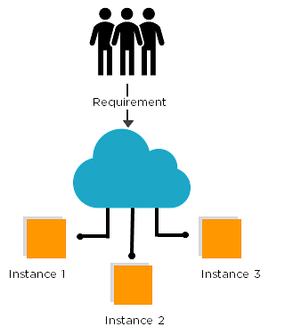

### 2. Amazon Elastic Beanstalk

Helps to scale and deploy web applications made with several programming languages like java, python, ruby, and .NET. EBS handles the deployment of the code as soon as it is uploaded.

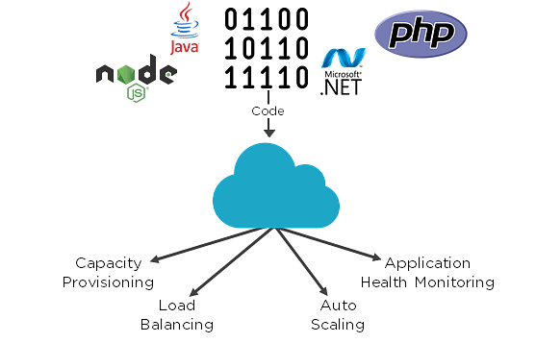

### 3. Amazon Lightsail

Enables a virtual private server (VPS) to be launched and managed with ease. It includes everything required by developers who want to start their projects quickly on a virtual machine.

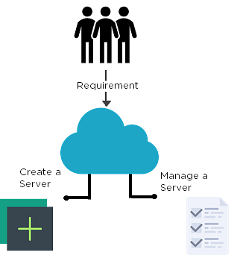

### 4. Amazon Lambda

It allows you to pay only for compute time. No need for provisioning and managing servers. Lambda executes code only when required, and scales automatically. It can handle a few requests a day, all the way to thousands a second.

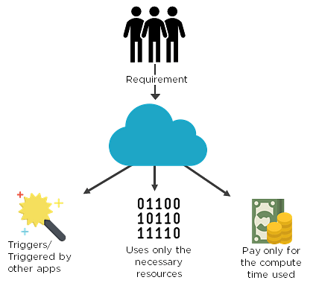

**Next up in the AWS fundamentals tutorial, let’s have a look at AWS Storage services:**

### 1. Amazon S3:

S3 is an object storage that can store and retrieve data from anywhere: websites, mobile apps, IoT sensors, and so on. It is durable, provides comprehensive security, and flexibility in managing data.

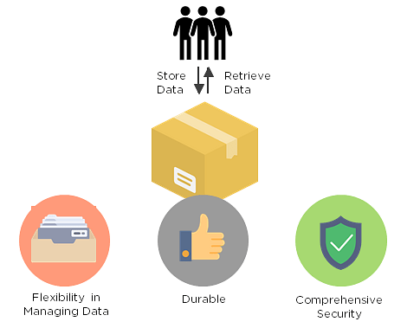

### 2. Amazon Glacier

Amazon Glacier is a cloud storage service that is used for archiving data and long-term backup. The glacier is used for data archiving and long term backup.

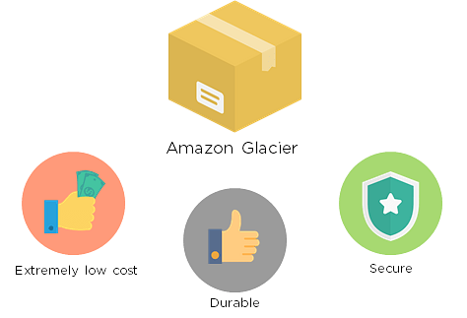

### 3. Amazon EBS

Amazon Elastic Block Store provides block storage volumes for instances of Amazon EC2. EBS is a reliable storage volume that can be attached to any running instance that is in the same availability zone.

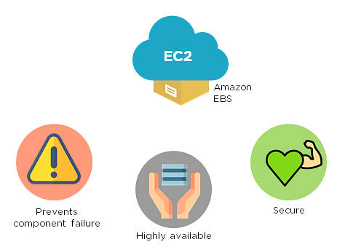

### 4. Amazon Elastic File System

Amazon EFS provides elastic file storage, which can be used with AWS Cloud Services and resources that are on-premises. It is easy to use and offers a simple interface that allows you to create and configure file systems quickly and easily.

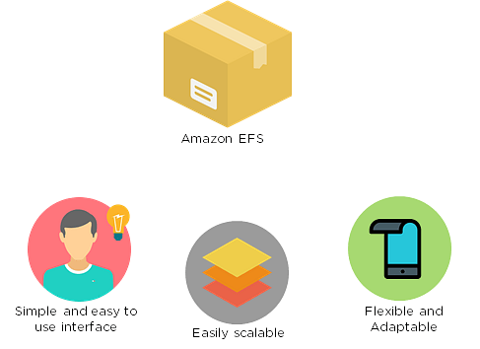

**Next up in the AWS fundamentals tutorial let’s have a look at the AWS Database services:**

### 1. Amazon RDS

Amazon RDS eases the process involved in setting up, operating, and scaling a relational database in the cloud. It helps with tasks like hardware provisioning, database setup, backup, and so on. It frees us from managing the hardware and enables us to focus on the application.

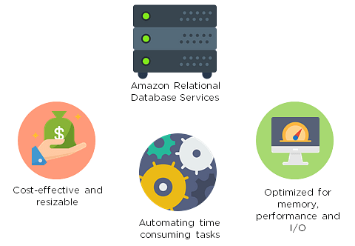

### 2. Amazon Redshift Amazon Redshift is a data warehouse that enables users to analyze their data using SQL and other BI tools. It is a fast, fully managed data warehouse. It also allows users to run complex analytical queries against structured data using sophisticated query optimizations.

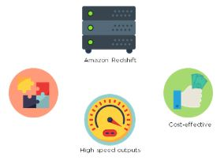

Wondering about other services? This AWS fundamentals tutorial has got you covered!

### 1. AWS Application Discovery Service

AWS ADS helps enterprise customers perform the process of migration by collecting information about their on-premises data centers.

Domain: Migration

### 2. Amazon Route 53

Route 53 is a scalable DNS web service to route end users to Internet applications.

Domain: Networking and content delivery

### 3. Elastic Load Balancing

Elastic Load Balancing automatically diverts incoming traffic into multiple targets.

Domain: Networking and content delivery

### 4. AWS Autoscaling

AWS Auto Scaling automatically adjusts resource usage to ensure steady performance at the lowest cost.

Domain: Management tools

### 5. AWS Identity and Access Management

AWS IAM helps users manage AWS resources securely, allowing users and groups to be allowed or denied permission.

Domain: Security

## What Can We Expect of AWS in the Future?

* A greater variety of cloud applications
* Expansion into other marketing units
* Greater innovation in AI
* Greater adoption by organizations

Now that you know how AWS is set to grow in the future let’s have a look at a practical example to deploy a web application in this AWS fundamentals tutorial.

### 2. Amazon Elastic Beanstalk

Helps to scale and deploy web applications made with several programming languages like java, python, ruby, and .NET. EBS handles the deployment of the code as soon as it is uploaded.



### 3. Amazon Lightsail

Enables a virtual private server (VPS) to be launched and managed with ease. It includes everything required by developers who want to start their projects quickly on a virtual machine.



### 4. Amazon Lambda

It allows you to pay only for compute time. No need for provisioning and managing servers. Lambda executes code only when required, and scales automatically. It can handle a few requests a day, all the way to thousands a second.



Next up in the AWS fundamentals tutorial, let’s have a look at AWS Storage services:

### 1. Amazon S3:

S3 is an object storage that can store and retrieve data from anywhere: websites, mobile apps, IoT sensors, and so on. It is durable, provides comprehensive security, and flexibility in managing data.



### 2. Amazon Glacier

Amazon Glacier is a cloud storage service that is used for archiving data and long-term backup. The glacier is used for data archiving and long term backup.



### 3. Amazon EBS

Amazon Elastic Block Store provides block storage volumes for instances of Amazon EC2. EBS is a reliable storage volume that can be attached to any running instance that is in the same availability zone.



### 4. Amazon Elastic File System

Amazon EFS provides elastic file storage, which can be used with AWS Cloud Services and resources that are on-premises. It is easy to use and offers a simple interface that allows you to create and configure file systems quickly and easily.



Next up in the AWS fundamentals tutorial let’s have a look at the AWS Database services:

### 1. Amazon RDS

Amazon RDS eases the process involved in setting up, operating, and scaling a relational database in the cloud. It helps with tasks like hardware provisioning, database setup, backup, and so on. It frees us from managing the hardware and enables us to focus on the application.

 

### 2. Amazon Redshift

Amazon Redshift is a data warehouse that enables users to analyze their data using SQL and other BI tools. It is a fast, fully managed data warehouse. It also allows users to run complex analytical queries against structured data using sophisticated query optimizations.

**Wondering about other services? This AWS fundamentals tutorial has got you covered!**

AWS ADS helps enterprise customers perform the process of migration by collecting information about their on-premises data centers.

Domain: Migration

### 2. Amazon Route 53

Route 53 is a scalable DNS web service to route end users to Internet applications.

Domain: Networking and content delivery

### 3. Elastic Load Balancing

Elastic Load Balancing automatically diverts incoming traffic into multiple targets.

Domain: Networking and content delivery

### 4. AWS Autoscaling

AWS Auto Scaling automatically adjusts resource usage to ensure steady performance at the lowest cost.

Domain: Management tools

### 5. AWS Identity and Access Management

AWS IAM helps users manage AWS resources securely, allowing users and groups to be allowed or denied permission.

Domain: Security

## What Can We Expect of AWS in the Future?

* A greater variety of cloud applications
* Expansion into other marketing units
* Greater innovation in AI
* Greater adoption by organizations

Now that you know how AWS is set to grow in the future let’s have a look at a practical example to deploy a web application in this AWS fundamentals tutorial.

**Use Case - Deploying an AWS application**

In this section of the AWS fundamentals tutorial, we will be using the services Route 53, CloudWatch, EC2 and S3, and Elastic Load Balancer to deploy a web application that will store data about customers subscribing to a particular website.

**EC2:**EC2 is used for provisioning the computational power required for the application.

**S3:**Provides additional storage.

**CloudWatch:**Helps monitor the web application. Here, we use it to see if we need to scale in or out.

**Route 53**: Helps to register a domain name for your web application.

**ELB:**It will create a monitoring environment while handling security and load balancing requirements of the application.

## Why is AWS EC2 important?

1. You don’t require any hardware units
2. Easily scalable (up or down)
3. You only pay for what you use
4. You have complete control
5. Highly secure
6. You can access your assets from anywhere in the world

## ****hat is AWS EC2?****

Among the vast array of services that Amazon offers, EC2 is the core compute component of the technology stack. In practice, EC2 makes life easier for developers by providing secure, and resizable compute capacity in the cloud. It greatly eases the process of scaling up or down, can be integrated into several other services, and comes with a plan where you only pay for how much you use it.

**1. Create an AWS account**

**2. Set up an EC2 instance**

If at some point in the future, you wanted to create an application using the resources you’ve stored on S3, you’ll need to create an instance EC2.

**2a) Choosing an AMI (Amazon Machine Image):**

An AMI is a template that is used to create a new instance—or virtual machine—based on user requirements. The AMI will contain information about the software, operating system, volume, and access permissions.

There are two types of AMIs:

i) Predefined AMIs: Amazon creates these, and the user can modify them.

ii) Custom AMIs: The user also creates these, and they can be reused. These AMIs are also available in the AMI Marketplace

**2b) Choosing an instance type:**

An instance type specifies the hardware specifications that are required in the machine from the previous step. Instance types belong to five main families:

i) Compute-optimized: For situations that require a lot of processing power

ii) Memory-optimized: For setting up something to do with your in-memory cache

iii) GPU optimized: For setting up a gaming system, or something with the requirement of a large graphic

iv) Storage optimized: When you need to set up a storage server

v) General-purpose: When everything is equally balanced

Instance types are fixed, and their configurations cannot be altered.

**2c) Configure Instance:**

You have to specify the number of instances, purchasing options, the kind of network, the subnet, assign a public IP, set the [IAM](https://www.simplilearn.com/tutorials/aws-tutorial/aws-iam) role, the shutdown behavior, etc. On that note, stopping the system and terminating the system under ‘Shutdown behavior’ are completely different things.

Stopping = Temporarily shutting down the system

Terminating = Returning control to Amazon

Under the advanced details, users can also add bootstrap scripts that are executed when the virtual machine starts up. It also offers multiple payment options, such as:

i) On-demand instances: Can be launched whenever the user requires normal rates

ii) Reserved instances: These instances are reserved for one year or three years. The entire amount has to be paid upfront or over a span of a few months.

iii) Spot instances: Bidding goes to the bidder with the highest bid. These instances are available at a lesser cost than on-demand instances.

**2d) Adding Storage:**

You’re tasked with deciding the type of storage, which could be:

i) Ephemeral Storage (temporary and free)

ii) Amazon Elastic Block Store (permanent and paid)

iii) Amazon S3

The size (in GBs), volume type, where the disk is mounted, and whether the volume needs to be encrypted needs to be specified. Free users get to access up to 30 GBs of SSD or magnetic storage (which can be found under ‘Volume Type’).

**2e) Adding tags:**

This helps to identify instances more quickly.

**2f) Configuring security groups:**

These are used to specify rules based on which users are given access to the EC2 instance. You set up the type of security, protocol, the port range, and source (from where the incoming traffic is coming from). Incoming traffic has to be explicitly specified, and outgoing traffic is open.

**2g) Review**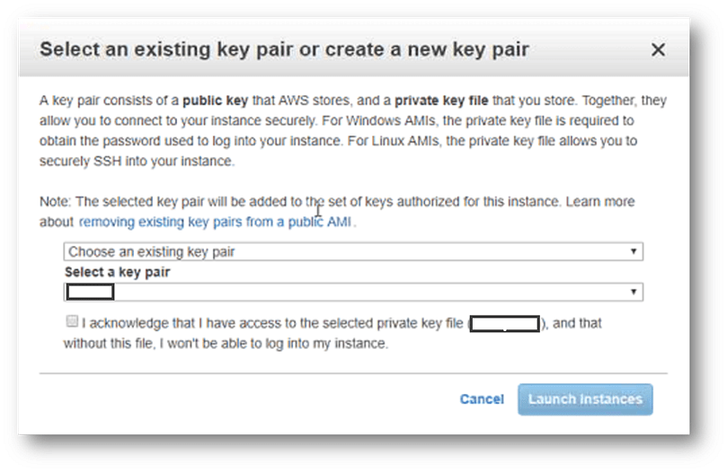

Click on ‘Launch’ and the instance is created. However, there’s a little more work to be done.

Fig: This dialog will pop up

**Private key**: The user downloads the private key

**Public key**: AWS uses the public key to confirm the identity of the user.

**After choosing to create a new pair, a new private key is downloaded as a .pem file.**

For the next step, we need to use the following tools: PuTTY and PuTTYgen. PuTTY is generally used when you need to connect a Windows system with a Linux system, which is what we’re doing now. PuTTY doesn’t accept .pem files.

So, using the PuTTY Key Generator, you create a new .ppk file.

Conversion> Insert Key

And load the .pem file.

Select “Save Private Key” and find a location to save the key.